**FACULTY OF COMPUTING**



**Database Systems**

**[Lab no.5]**

Submitted To: Ma’am Ayesha Akram

Submitted From: Nida Iqbal

SAP ID: 58976

**TASKS**

**Task 1: Retrieve name, continent and region columns from the country table.**



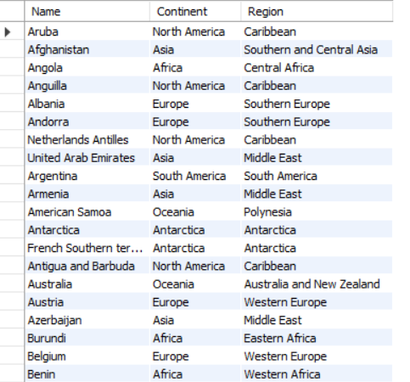

**Task 2: Retrieve all the countries whose name starts with the letter 'A'.**



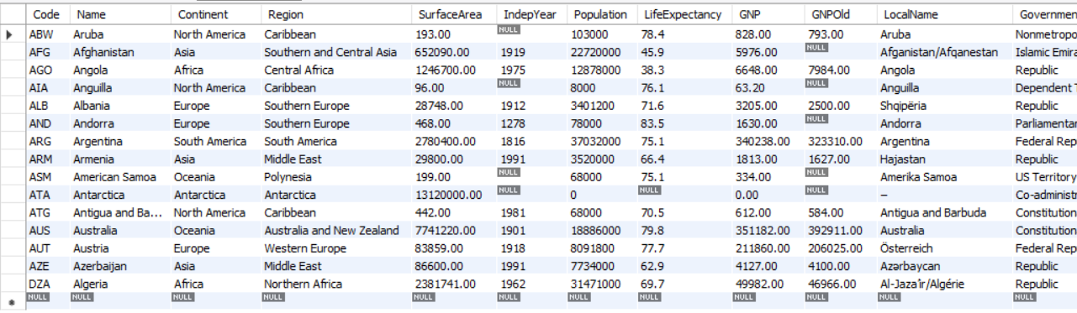

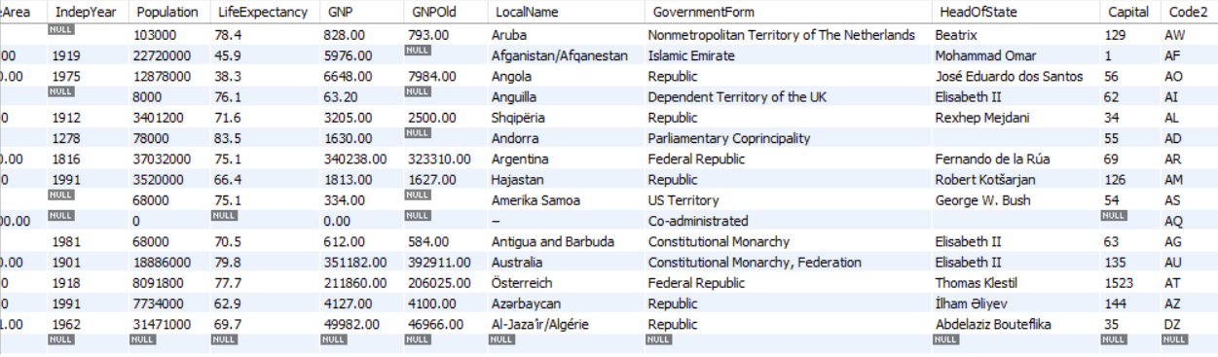

**Task 3: Retrieve all the countries that fall under Asia Continent'.**



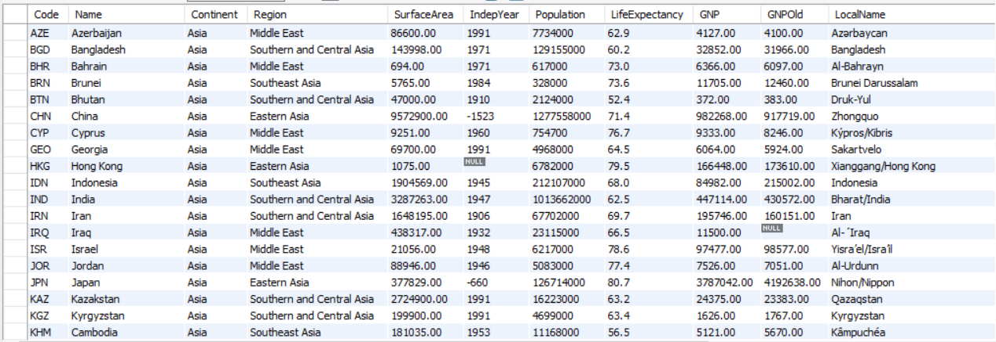

**Task 4: Retrieve all regions who have life expectancy greater than 80%.**



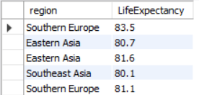

**Task 5: Find the distinct population in the city table.**



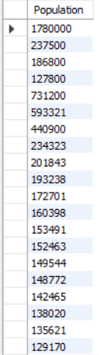

**Task 6: Retrieve first ten country languages.**



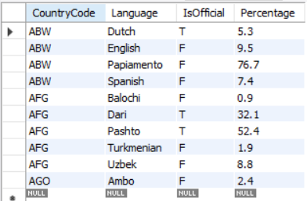

**Task 7: Display the countries that start with the alphabet a.**





**Task 8: Retrieve all the countries whose government is republic type or US Territory.**



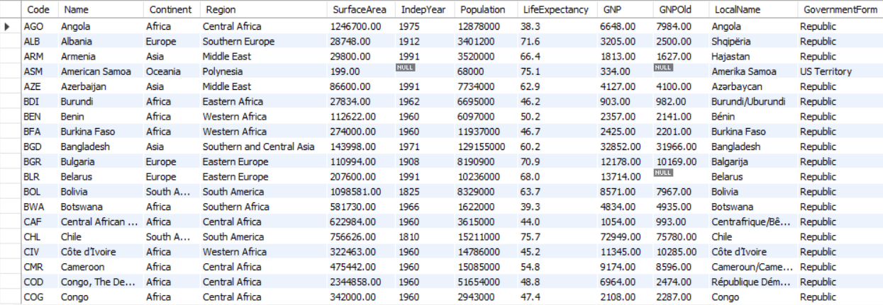

**Task 9: Retrieve the cities with IDs 1, 5, and 9.**



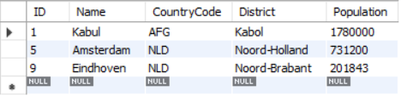

**Task 10: Retrieve all countries whose speaking language is English.**

